Arbury Park Outdoor School
Risk Management Plan

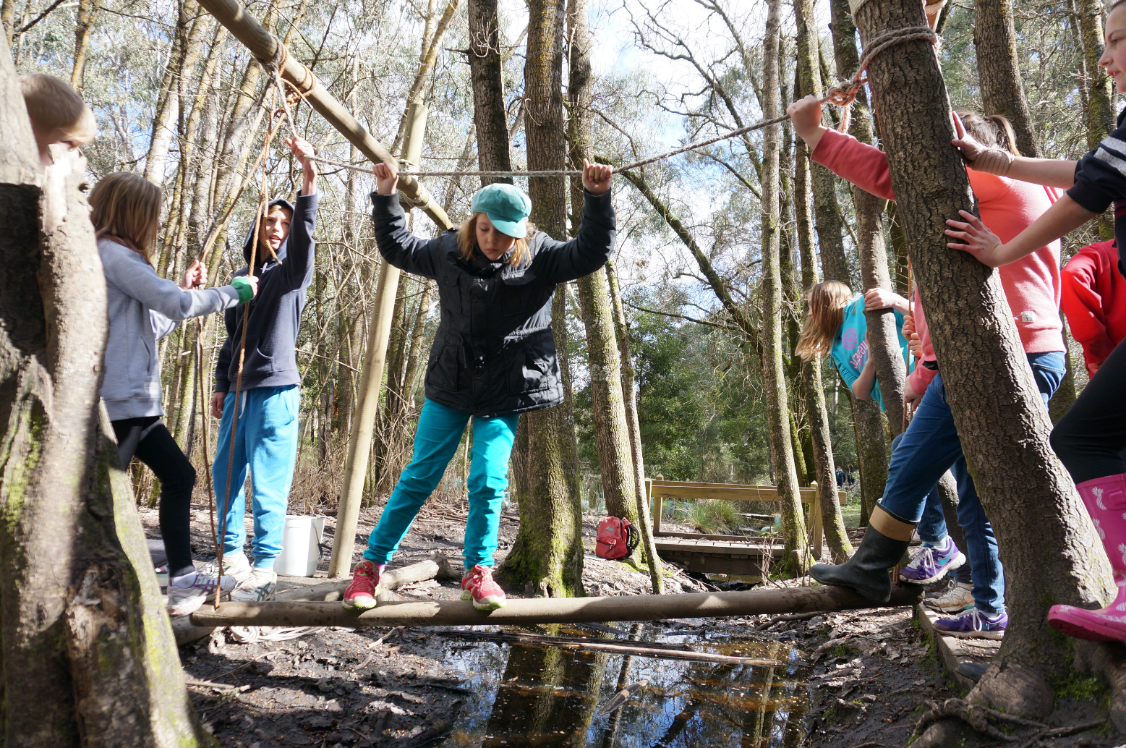

Arbury Park Road, Bridgewater SA 5155
Tel 08 8339 3237 Fax 08 8339 3313 DL.1426.info@schools.sa.edu.au www.arburypark.sa.edu.au

Arbury Park Outdoor School Risk Management Plan

This document supports teachers and leaders in preparation for their camp at Arbury Park Outdoor School (APOS). It provides details about APOS that can be used to complete the following documents required by the department.

- Sports, adventure, camps and excursions risk management plan (August 2023).
We have identified potential risks and included the risk controls we undertake to prevent / reduce these risks.
- Consent form for camp, excursion, sporting or adventure activity (July 2023)
We have provided text you can use when completing the activity information sheet on the student consent forms.

This document is based on the Department for Education policy, plans and procedures located at https://edi.sa.edu.au/hr/for-managers/health-and-safety/creating-a-safe-workplace/camps-and-excursions

Benefits of bringing your students to Arbury Park Outdoor School

The benefits of outdoor learning:
- Making connections with the natural world that supports all life.
- Building new knowledge, connections and understandings in context.
- Engaging emotions and the senses in a holistic learning experience.
- Inspiring and motivating learners to take personal and collective action.

The benefits of our residential setting:
- Promoting cooperation and wellbeing.
- Building relationships and a sense of community.
- Promoting ecologically sustainable ways of living.
- Inspiring ongoing learning for students and teachers alike.

Arbury Park Outdoor School Values

Curiosity is an eagerness to discover new things, to wonder and learn. When we are curious we explore the mysteries of our world.

Care means giving love and attention to people and things that matter. When we care about something or someone we try to give our best.

Community is about the connections in our lives; connections between each other, with places and with things. Our community is the web of our relationships. It gives us a sense of belonging.

“Camps and excursions are a valuable teaching and learning experience providing an opportunity for children and young people to learn from the wider community, build on the curriculum and reinforce site based learning.” Camps and Excursions, Department for Education, 2020.

General Information relating to risk

- We are a Department for Education site. All staff have current working with children checks and 004 first aid training.
- All teaching staff carry a first aid kit and mobile phone during activities.
- First aid supplies, an Epipen and first aid room are located next to the main office.
- On day one of camp, each school group completes an evacuation drill and discusses the Arbury Park Outdoor School values and safety information about steep hills, SunSmart, snakes, and hopper ants.
- Our Bushfire Action Plan is accessible via our website.
- Some of the risks and risk controls cross over activities. To minimise repetition, most risks and controls have been documented only once.
- Our risk identification is based on our knowledge and experience. This document does not include every possible eventuality that may arise.
- This document does not preclude visiting teachers from carrying out their own risk assessment that may be specific to the needs of their student group, for example special needs students.
Consent form additions

Schools are required to use the ED170 consent form which has a space for additions in the Activity Information section.

Please use the text below to inform parents of our activity descriptors as well as consent for three specific requirements at Arbury Park Outdoor School.

Activity Information (on ED170 form)

REASON FOR AND DESCRIPTION OF PLANNED ACTIVITIES – INCLUDING SPECIALISED CLOTHING OR EQUIPMENT THAT WILL BE REQUIRED AND PROGRAMS PLANNED FOR STUDENTS UNABLE TO ATTEND | Find details of the activities and risk management plans at Arbury Park Outdoor School at https://arburypark.sa.edu.au/curriculum/  Parental consent for specific requirements at Arbury Park Outdoor School  To the best of my knowledge, he/she is not presently carrying a contagious disease such as gastroenteritis or have symptoms of fever and dry cough that could put other students at risk. I agree to withdraw my child from participating in the camp if he/she has any episodes of vomiting or diahorrea within 48 hours of the scheduled departure time.  Signed …………………………………………….. Dated …………………  I give consent for my 6 to 8-year-old child to sleep on a top bunk that meets current safety standards.  Signed …………………………………………….. Dated …………………  I give consent for my child to participate in orienteering activities that involve indirect supervision.  Signed …………………………………………….. Dated …………………

Supervision Ratios

The department’s 2020 Camps and Excursions Procedure explains supervision requirements and ratios for camps and excursions. It lists eight factors that influence choices about the “level of supervision required to support all children and young people’s safety and wellbeing” (p.14). For example, the age of the children and young people, the location, and the nature of the activity.

The procedure specifies supervision ratios (p.16) 1:6 for receptions to year 2
1:10 for years 3 to 6
1:15 for years 7 to 12
Importantly, the procedure also states that:

“All specified ratios should be complied with unless the program is modified to allow for an increase or decrease of supervisors and this modification is identified in the application to conduct an excursion approved by the site leader” (p.17)

Conditions at Arbury Park Outdoor School that might allow for a “decrease of supervisors” (p.17 of procedure) include:
- Arbury Park Outdoor School is a Department for Education site. It operates under the same high levels of scrutiny and WHS compliance as other schools.
- Maintenance schedules and risk assessments meet or exceed departmental requirements.
- Qualified, experienced staff deliver the school programs.
- Emergency procedures are thoroughly documented, rehearsed and evaluated.
- Arbury Park Outdoor School is an accredited campsite through the Quality Tourism Framework program.

Decisions about supervision and adult:student ratios are a matter for the camp teacher-in-charge and site leader. Any variation from the ratios specified above requires approval by the visiting school’s site leader on ED169 Application to Conduct a Camp or Excursion.

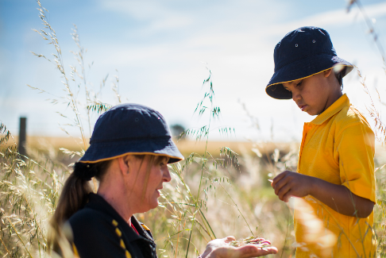
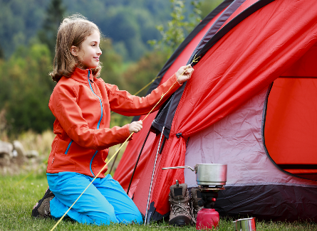
Sports, adventure, camps and excursions
risk management plan

Sports, adventure, camps and excursions risk management plan for
Arbury Park Outdoor School (completed by visiting schools)

Site name
Pick up location, destination, method and means of transport (including proposed route) | Destination: Arbury Park Outdoor School, Arbury Park Rd, Bridgewater 83393237  Pick up:  Transport:
Date and time of departure/return e.g. from the site to each destination and returning to the site
Proposed activities | Outdoor learning. See camp program and/or Arbury Park website for specific activities. https://arburypark.sa.edu.au/curriculum/
Class and year level
Number of children/ young people
Number of employees/ volunteers

Key contacts |  | Name |  | Contact number
Site leader
Teacher-in-charge/responsible person
Alternative teacher contact
Health and safety representative
Site point of contact
First aider
APPROVAL
Acknowledgement: Safety risks have been identified for the listed camp / excursion with controls implemented to effectively manage risks to the health and safety of participating employees, volunteers, children, and young people.
Requirements in this document must not be altered and it must be available at the site for parent inspection requests. This form must be completed to ensure compliance with the Education and Care Services National Regulations and departmental policy before seeking parent/legal guardian consent and before a camp or excursion takes place.
Position | Name |  | Signature |  | Date
Teacher-in-charge
Site leader

Minimum requirements
Planning | - ED169 has been completed (see: Approvals).  - 1 teacher is assigned as the teacher-in-charge, as the delegate of the site leader, to provide leadership and control of the camp or excursion (see: Supervision).  - The venue for excursion or camp location is reviewed in the initial planning stage to determine the suitability of location. The location must have an emergency management plan (see: Planning).  - The emergency management plan in this form is reviewed and updated, if required (see: Emergency management).  - Additional hazards and controls are listed on page 2 of this form, if required (see: Risk management).  - For a sporting or adventure activity, the sporting and adventure activities standard and activity instructions must be followed; the instructor competency and supervision ratios must be adhered to (see: Sporting and adventure activities).  - A parent or guardian signs the excursion/camp consent form. (see: Consent).  - Weather forecast to be checked leading up to and during the camp/ excursion (see: Supervision).  - Monitoring of CFS bushfire alerts and special consideration for camps in bushfire prone areas. Cancel the camp/excursion if the destination is in a bushfire prone area during an extreme fire danger warning, a total fire ban or if there is a bushfire (see: Bushfire prone areas).  - Ensure appropriate communication devices with adequate service coverage are available (see: Planning).  - For activities without a prescribed ratio, or the risk assessment does not indicate a higher ratio is required, the minimum supervision ratios are in place (see Supervision):  - 1:6 for preschools to year 2  - 1:10 for years 3-6  - 1:15 for years 7-12.  - Ensure there is adequate supply of water and food, sun protection and appropriate clothing for weather conditions (see: First aid, safety and equipment).  - List of children and adults attending the camp/excursion and contact information for each person (see: Supervision).
Conduct and behaviour | - Children and young people follow the school behaviour code (see: Standards of conduct).  - Supervisory staff team members follow the Code of Ethics for the South Australian Public Sector (see: Standards of conduct).  - Supervisory volunteer team members follow the Expected Behaviours for Volunteers, outlined in the Volunteer Agreement. (see: Child protection).  - All supervisors, including parents, volunteers and instructors must hold a child related screening clearance in accordance with the Screening and suitability (child safety) policy (see: Child protection).  - Volunteers have met screening and suitability requirements, completed an induction and are aware of the protective practice guidelines (see: Child protection).  - All participants are briefed on any identified conditions of the children/young people, the emergency and contingency plans, any relevant specialized or technical skills of supervisory team members, their roles and responsibilities and any relevant hazards (see: Risk management).  - Children and young people are accounted for at regular intervals; with a head count occurring each time children/young people board and disembark transport; and enter and leave the location, checked against the attendance record. (see: Risk management).  - Alcohol or drugs must not be consumed; and supervisors must not smoke within 10 meters of the camp perimeter or in view of children/young people (see: Risk management).
First aid | - For camps and adventure activities 1 person is trained in ‘HLTAID012 – emergency first aid in education and care settings’ for every 25 people.  - Where it may take greater than 2 hours for medical assistance or a medical retrieval to arrive, at least 1 first aider must be trained in ‘HLTAID013 –first aid in remote site’.  - For excursions, consider the risks of the location or activity being undertaken; and any pre-existing medical conditions of the participants. Ensure that you have one of the following:  - a designated first aider in the group  - a teacher trained in first aid  - a first aider available at the location  - access to local area GP/medical facilities  - a paramedic in close proximity.  - Appropriate type of first aid kits is available e.g. basic first aid kit for each first aider, remote first aid kit, Epi-Pen etc.  - The first aiders have a copy of any individual first aid plan where a child or young person has a known health condition and the first aid response is NOT the standard first aid response for that health condition.  - Medications required for children and young people must be easily accessible and secured to prevent unauthorised use.  - Leadership team provided with medical information for each child (where applicable).  - Children and young people with complex and invasive health needs must be provided with the opportunity to attend camps/excursions and be supported by a competent person to manage their health needs.
Transport | - The bus is fitted with a current safety label (safety triangle on windscreen) and the bus driver holds a valid licence.  - The bus company has a contingency plan in the event of mechanical failures.  - Check no one is left on a bus by walking the length of the bus and conducting a visual inspection including checking under seats.  - Private motor vehicles are used as a last resort with a written agreement signed prior to the event (use the agreement form and employees also must complete ED008) and parental consent sought.  - Driver’s licences are unrestricted and valid; “L” plate drivers are not to transport children or young people.  - Complete a long distance travel plan if an employee is driving greater than 300kms in a rural location.  - Requirements for seatbelts or safety restraints when transporting children are implemented as required  - For education and care services, ensure there is a process for entering and exiting the service and the pick-up location or destination (as required) and procedures for embarking and disembarking the means of transport.

Follow the steps on page 10, and in the table below list any additional hazards and controls for your sport, adventure, camp, and excursion that are not already listed on page 5 of this document. The safety requirements outlined in the camps and excursions intranet and the sporting and adventure activities intranet identify further hazards and controls that may also need to be considered. NOTE: Early childhood sites must identify and address all water hazards.

Arbury Park Outdoor School risk assessment plan
Hazard identification  (What is the issue of concern?) | Risk Controls  (What are you doing to eliminate or reduce the risk?) | Risk (With all controls in place)
Freshwater life  Student falls into the pond and is at risk of drowning or hypothermia (winter months). | - APOS ponds are constructed as shallow water bodies with gently sloping sides with reaching poles stored at each pond.  - A minimum of 2 supervisors. Adult to student ratio 1:6 for Reception - year 2, 1:10 for years 3 - 7, 1:15 for years 8-10.  - Model balanced netting technique before students start netting.  - Identify safe sampling sites around the pond edge for students in lesson introduction.  - Brief visiting staff and parents on the need to monitor students at all times.  - Teaching staff notify principal if grounds staff need to carry out maintenance of pond edges. | Low
Hiking  - Student suffers hypothermia or heat exhaustion.  - Student falls and suffers injury.  - Student becomes ill from medical condition.  - Student becomes separated or lost from group.  - APOS teacher leading group suffers serious injury.  - Student is bitten by snake. | - Group leader has hiking experience, is familiar with local conditions and carries a mobile phone and/or UHF radio.  - 2 adults per group, one with leader experience. Adult to student ratio 1:10 for years 3-7, 1:15 for years 8-12. Maximum group size is 20 students.  - Choose route that matches physical ability of group participants.  - Check clothing and footwear and all are carrying full personal water bottles prior to hike.  - APOS leader reminds students to bring medication before leaving camp.  - Appoint student ‘leader’ and ‘tail ender’. APOS teacher to lead from the front in steep, wet or dangerous terrain. Waking at a comfortable pace for the group.  - Explain the importance of staying together, use of whistles and shouting by leader to establish contact if a student is missing.  - Cancel or shorten hikes in hot weather 30°C locally or above. Adjust pace and frequency of rest stops. Cancel hike on days of strong winds.  - Snake safety addressed during camp safety discussion on day 1. | Medium
Orienteering  - Student becomes separated or lost from group.  - Student falls and suffers injury.  - Student becomes ill from medical condition.  - Student suffers hypothermia or heat exhaustion.  - Student is bitten by snake. | - APOS leader has orienteering experience, is familiar with all orienteering courses and local conditions.  - APOS leader chooses an orienteering course that matches the age and physical ability of group participants.  - Required ratios of 1 : 10 for years R to 2, 1 : 15 for years 5 to 7, 1 : 15 for years 8 to 12 with minimum of 2 leaders are met.  - Courses have specifically made orienteering maps that include defined boundaries with clear features on APOS grounds.  - Lesson introduction (by APOS leader) for students and visiting adults includes orienteering skills and practice, safety procedures, identification of boundaries, the need to work in pairs or threes, the use of whistles to bring group back to the meeting point and reminds students to take medication with them.  - APOS leader uses a trial checkpoint to check proficiency of learners before they commence orienteering. Brief client adults on the locations each is designated to monitor and coach students when necessary.  - Cancel or modify orienteering in inclement weather.  - Snake and slow down safety addressed during camp safety discussion on day 1. | Medium

Hazard identification | Risk Controls | Risk
Lost/runaway student  - Student becomes lost.  - Student may be injured and unable to seek help.  - Student may be at risk of harming themselves. | - All staff and students instructed about the signals to call them back at the end of lessons and for meal times.  - Visiting teachers provide information to APOS teachers about any known high risk students.  - When notified of missing student, assess the information and the level of risk, if known, for this student (has it happened before?, is there a pattern of behaviour?)  - Depending on level of risk, conduct an APOS coordinated search of most likely locations (dorms, gym, and favourite places). Provide a UHF radio for each member of the search party, for real time communication. | Low
Non-programmed time  - Student falls into a pond and is at risk of drowning.  - Student falls and suffers fracture, sprain, severe bleeding, head injury.  - Student becomes ill from onset of known medical condition.  - Student with no previous indication of allergy suffers severe reaction. | - APOS coordinator and client teachers provide students with clear safety instructions and details of areas for supervised free time (see APOS supervision policy in Visiting Teachers Handbook). Safety discussion on day 1 of camp.  - Ponds are out of bounds and the gym must be supervised by a teacher.  - Visiting teachers supervise students during non-programmed time.  - APOS camp coordinator explains that 4 is the minimum number for an indirectly supervised exploring group.  - Visiting teacher(s) to check that medication is with student or have alternative plan during periods of non-programmed time.  - Advise students that if they suffer a bite or sting that is very painful, or causes breathing problems, they must report it immediately to a teacher.  - APOS hazard reporting system in place in addition to safety audits. | Medium
Evening supervision  - Student or adult receives injury and requires medical attention.  - Student or adult becomes unwell.  - Student goes missing.  - Teacher receives injury using catering equipment or campfire.  - Emergency situation (fire, falling branch).  - Water or electricity supply fails.  - Intruder on site.  - Student or adult receives bullying or harassment (including sexual harassment).  - Shower – slip, privacy compromised. | - First aid room provided for visiting schools use.  - Schools bring 1:25 teachers:students that have HLTAID004 first aid training.  - Vehicle available for emergency use.  - WHS procedures followed (Department for Education site).  - At 4.30pm on day one, the APOS coordinator explains that their teachers and adults are now in charge of the evening program and supervision. Explanation about trust and boundaries, and that exploring groups have at least four students.  - Catering staff demonstrate to visiting teachers safe procedures for providing supper. Campfire instructions provided.  - On day one all students complete a fire drill and discuss emergency and safety procedures.  - Teacher in charge is shown emergency procedures by APOS camp coordinator on day one.  - Emergency numbers and information displayed in the visiting teacher room (includes the caretaker and principal ph. numbers).  - A total of 9 supervising adult beds in 6 separate supervisors’ rooms. Additional supervising adults’ beds are available.  - Showers provided with lockable doors and are all tiles are rated non-slip. | Medium
Campfire  Student is burnt by fire directly or indirectly (food, sticks, camping utensils). | - Guidelines for camp fires in Evening Activities folder for visiting teachers.  - Staff members to monitor student behaviour and safety around campfire.  - Staff members brief students on fire safety (use of sticks and equipment) and monitor student behaviour around campfire.  - No fires on total fire ban days and campfire cancelled if extreme weather threatens safety.  - Jerry cans of water are available for burns and fire management.  - A fire pit area is defined on clear, even ground. | Medium

 | Hazard identification | Risk Controls |  | Risk
Sleeping overnight  - Students sleeping on top bunks fall and are injured.  - Student or adult receives bullying or harassment (including sexual harassment). |  | - Bunks built to comply with Australian design standards (4220-2010).  - Children under six years must not use top bunks. Parents give written consent for 6-8 year old children to sleep on top bunks.  - Expectations for behaviour in dorms are explicitly outlined on day one of camp. Students not permitted to use dorms as a play space in free time.  - Student wishing higher levels of privacy can use cubicles in showers for changing.  - A total of 12 supervising adult beds are available in 6 separate supervisors’ rooms. Additional supervising adults can:  - Sleep two or more team members in the dorms with students (no member on their own with students) or  - Sleep on mattresses on the floor of a separate nearby room. | Medium
Vomiting and/or diarrhoea illness  - Student(s) or staff arrive at camp vomiting / diarrhoea.  - An individual becomes dehydrated through continuous vomiting and/or diarrhoea.  - More than one student/adult becomes ill with continuous vomiting and/or diarrhoea.  - Vomiting and/or diarrheal illness shows signs of rapidly spreading to other campers.  - With large numbers of people ill, dormitories or dining room become contaminated and infect future clients. |  | - Parents sign consent form indicating that children will not attend camp if they have suffered vomiting illness in previous 48 hours.  - All hand washing under running water with soap from dispenser.  - Move person to first aid room, monitor, provide water/lemonade. If first aid room unable to be used as sick numbers grow, isolate all sick persons in one area, indoor or outdoor as weather permits.  - Visiting school responsible for care and to organise transport home.  - Clean up any vomit with disinfectant to minimise risk to others.  - Thorough disinfect of all dormitories including wipe over vinyl mattresses with disinfectant after group leaves and clean blankets. Thorough disinfect of dining room, including disinfection of floor, tables, benches and door furniture.  - Kitchen follows HACCP (Hazard analysis and critical control points) procedures to ensure food prepared is safe, and is randomly audited by the Environmental Health Officer of Adelaide Hills Council.  - Catering staff hold current Safe Food Handling Certificate. | Low
Asthma  - Student suffers asthma attack.  - Student does not follow or have an asthma action plan (AAP).  - Student does not carry appropriate medication.  - Terrain and program activities at APOS may require more strenuous effort than usual.  - Cold air or airborne particles trigger asthma. |  | - Visiting teacher(s) are aware of and monitor student’s AAP.  - Visiting school teacher in charge notifies APOS coordinator of AAPs that will limit activity participation during camp.  - APOS and client teachers consider participation in various activities in context of student’s AAP and monitor students for possible signs of asthma attack.  - Modify activity program for students with significant reaction to particular environmental triggers.  - Visiting teachers check that students carry medication if necessary.  - APOS teachers carry spare asthma pack in their personal first aid kit. | Medium

 | Hazard identification | Risk Controls |  | Risk
Extreme weather  - Student is injured by tree / branch.  - Student becomes heat exhausted.  - Student becomes hypothermic.  - Student(s) affected by lightning strike. |  | - Check for severe weather warning issued by BOM. Limit exposure by rescheduling outdoor activities until severe weather has passed. Deliver all or part of the lesson indoors, in open areas or near buildings.  - Explain the need to drink regularly in hot conditions. Cancel or shorten hikes or vigorous activities in hot weather, eg above 30°C. No hikes on Total Fire Ban days.  - APOS teacher checks clothing prior to outdoor activity, limits exposure to short periods, teaches close to shelter and cancel outdoor activities if necessary.  - Should thunder storms occur while program activities are taking place outdoors, the group moves to an open area away from ridge, hill tops and tall trees. | Medium
Bushfire emergency  - Staff and students suffer smoke inhalation injury and/or burns. |  | - Where the next day fire danger forecast is Catastrophic APOS must close.  - When the 4-day fire danger forecast is High or Extreme APOS will make early contact with the visiting school to prepare to cancel a camp scheduled for that period, without financial penalty.  - Where the fire danger is forecast High, Extreme or Catastrophic while a camp is in progress, an early end to camp and transport home will be negotiated.  - The dining room/admin building is a Bushfire Refuge, with a roof mounted deluge system (sprinklers), shutters, laminated glass windows, bronze screening and colorbond sheet on northern side.  - The roof sprinklers have a dedicated firefighting supply of approx. 180 kilolitres and will run all sprinklers (refuge and dormitories) for one hour. They have separate dedicated diesel pumps.  - An additional 64 kL of stand-alone tank water and hydrant system is dedicated for CFS use only in defending APOS. | Medium
Kitchen  - Student becomes ill or has anaphylactic reaction due to a food allergy.  - Student becomes ill due to food borne contamination. |  | - Schools and parents provide catering information including individual dietary forms for those with specific needs.  - Catering staff are trained and aware of dietary needs. They provide a safe food preparation area for students with severe allergies.  - Parents and teachers are invited to contact the Catering Manager to discuss dietary needs.  - Kitchen follows HACCP (Hazard analysis and critical control points) procedures to ensure food prepared is safe.  - Catering staff hold current Safe Food Handling Certificate.  - Kitchen is randomly audited by the Environmental Health Officer. | Medium

Document submitted by: ………………………………………………………………………………………………..………………..…………. Date submitted: …………………………………………………………………
Document prepared by: Louise Petherick (Arbury Park Outdoor School) Last updated: 5/9/23 Louise Petherick

Sports, adventure, camps and excursions risk assessment for additional hazards

Step 1: Have a look at WHS safety management intranet and see if there are any activity hazards that are not already covered.

Step 2: Identify controls for your remaining hazards. Use the hierarchy of control chart to help select controls that provide the highest level of protection to employees and participants.

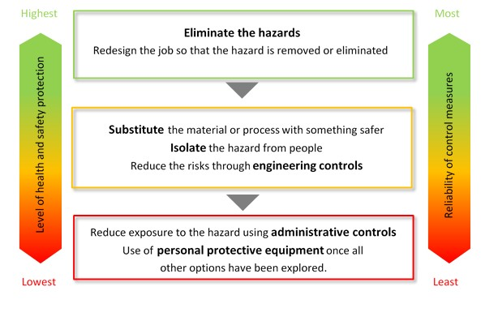

Step 3: Assess the risk of the identified hazard assuming all controls are in place.

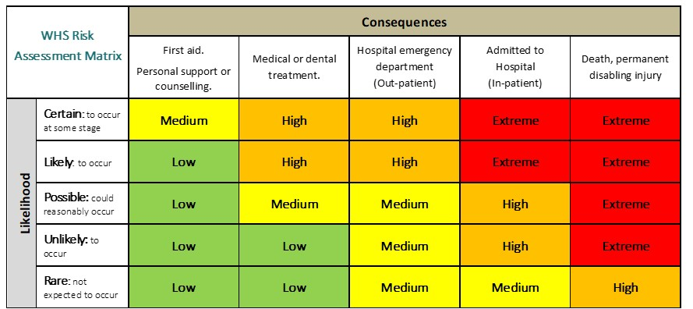

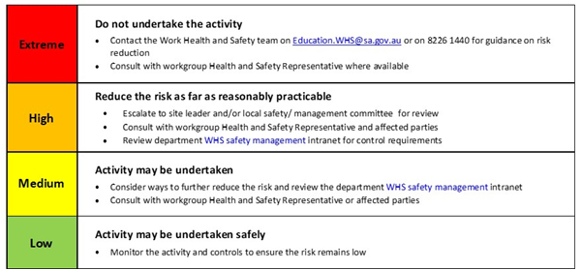
Step 4: Check the assessed risk level and undertake the associated action.
Other items that should be taken on the camp/excursion

List any other items (in addition to the minimum requirements listed above) that will be needed on the camp or excursion

Emergency management plan
- Provide immediate first aid assistance or care prescribed by an individual health support plan and/or isolate any person with an infectious disease.
- Call 000 and advise them of the closest vehicle entry point.
- Ensure communication with emergency services is maintained.
- Send an employee or volunteer to the point where emergency services will enter the location, if it is safe to do so.
- Collect the attendance list, individual first aid plans and this plan.
- Evacuate all people to the nominated emergency assembly point.
- Once at the assembly point, check all people are accounted for.
- Maintain a record of actions/decisions undertaken and times.
- Report the emergency/evacuation to the site leader of the school or preschool by using the agreed form of communication tool i.e. mobile phone.
- Site leader will then notify:
- Education Director
- Report on IRMS as a notifiable incident.
- Wait for emergency services to arrive or provide further information/instruction.
Teacher in charge to arrange for parents to be informed.
Note method for communicating with the school/preschool contact:
The school/preschool contact must be contactable at all times, have a copy of this risk management form, be aware of the emergency management plan, have the attendance lists, child/young person health and personal care information, contact numbers of parents/legal guardians, and the itinerary.
Note nearest suitable transport: Car on site.
Note distance from help and method for obtaining it:
Call OOO. As we are located in the metropolitan area, ambulance and other emergency services are prompt.

List any additional contingencies (i.e. in the event a person becomes lost):
- Leader assesses situation and ensures safety of the group.
- Follow relevant procedure (eg. APOS Bushfire plan or lost/runaway student procedure).
- Administer appropriate first aid until help arrives.
- Contact the office and/or emergency services.
- Contact visiting school and parents when necessary.

Following the management of any critical incident, record incident on medial incident report form, and / or lodge a report on Incident Response Management System (IRMS).

Call-in procedure
The following process must occur when the camp or excursion is in a remote or isolated location.
NOT APPLICABLE TO ARBURY PARK OUTDOOR SCHOOL
- The teacher-in-charge or delegate must contact a designated person at the site to inform them they have safely arrived; and call prior to leaving the camp or excursion location with an estimated time of arrival back at the site.
- The teacher-in-charge must provide a time that the check-in will occur.
- If the check-in does not occur after 20 minutes of the agreed time, the site designated person must phone the teacher-in-charge or an alternative contact.
- Once 2 unsuccessful attempts have been made to contact the teacher-in-charge or alternative contact within 30 minutes the designated person at the site must inform the site leader and call 000 for police assistance.

Emergency management map for your remote or isolated destination
The below map is not required in built-up residential areas. It is only required when an ambulance station is not within 30kms of the camp or excursion location. You must include as indicated in your emergency management plan the emergency vehicle access point and the emergency assembly point.

INSERT SITE LOGO | ED170  Updated: 06/23
CONSENT FORM FOR CAMP, EXCURSION, SPORTING OR ADVENTURE ACTIVITY
(Note: that parents includes independent students, caregivers (for children in care) and authorised persons (standalone preschools), see definitions of the camps and excursions procedure)
Requirements in this document must not be altered. Please use block letters when filling out this form
As a parent of:
STUDENT/CHILD’S NAME
I:
PARENT NAME
give my consent for [name of child] to participate in:
NAME OF CAMP/EXCURSION/SPORTING OR ADVENTURE ACTIVITY
do not give my consent for [name of child] to participate in any religious activities outlined below (if applicable)
at/on:
LOCATION
 | FROM: |  |  |  |  |  |  |  | TO: |  |  |  |  |  |  | OR ON:
Does your child have any health support, or medication administration needs that should be considered for camps, excursions etc? Yes No N/A
If Yes, has a care plan/medication agreement been provided to the school/preschool? Yes No N/A
If No, please provide a completed care plan/medication agreement to the school/preschool on completion of this form.
Any other matters that may impact your child’s participation in the above activities safely? Yes No
If Yes, please outline details to the school/preschool in the box below.
Details of planned activities, transport arrangements, anticipated number of students/children and supervising teachers/instructors are provided on the information sheet below.

Agreement
- I agree to delegate my authority to supervising teachers/instructors. Such supervisors may take whatever disciplinary action they deem necessary to ensure the safety, well-being and successful conduct of the students as a group and individually.
- In the event of an accident or illness and contact with me being impracticable or impossible, I authorise the teacher-in-charge to arrange whatever medical treatment a registered medical practitioner considers necessary. I will pay all medical and dental expenses incurred on behalf of my child. I understand that I may seek payment of any ambulance invoice by the department if my child does not have private ambulance cover.
- Where appropriate I have also attached additional or updated health care information, including details of any additional health support he/she requires to undertake the above activities safely.
- The information given is accurate to the best of my knowledge.
- I acknowledge that a risk management form is available upon request for my inspection at the site.
Signed: |  | Date: / /
Parent (in case of emergency)
NAME
RELATIONSHIP TO CHILD
TELEPHONE (1) |  |  | TELEPHONE (2) |  |  | MOBILE
Student Medic Alert Number (If applicable):
*Any health care information provided is not intended to prevent your child participating unless specific medical advice warrants exclusion. The health care information you supply to the school/preschool will be treated confidentially. Such information is sought in order to protect and assist the student so the activity may be a safe and enjoyable experience. Please contact the teacher-in-charge if you wish to discuss any health care problems.
ACTIVITY INFORMATION SHEET
(Note: for a series of activities that take place on a regular basis (including regular outings), list all individual activities, dates, locations, cost, transport, supervision arrangements and start and dismissal times)

REASON FOR AND DESCRIPTION OF PLANNED ACTIVITIES – INCLUDING SPECIALISED CLOTHING OR EQUIPMENT THAT WILL BE REQUIRED AND PROGRAMS PLANNED FOR STUDENTS UNABLE TO ATTEND | Find details of the activities and risk management plans at Arbury Park Outdoor School at https://arburypark.sa.edu.au/curriculum/  Parental consent for specific requirements at Arbury Park Outdoor School  To the best of my knowledge, he/she is not presently carrying a contagious disease such as gastroenteritis or have symptoms of fever and dry cough that could put other students at risk. I agree to withdraw my child from participating in the camp if he/she has any episodes of vomiting or diahorrea within 48 hours of the scheduled departure time.  Signed ………………..……………………………….. Dated …………………  I give consent for my 6 to 8-year-old child to sleep on a top bunk that meets current safety standards.  Signed …………………………………..…………….. Dated …………………  I give consent for my child to participate in orienteering activities that involve indirect supervision.  Signed …………………………………………………………….. Dated …………………
TRANSPORT ARRANGEMENTS – INCLUDING DESCRIPTION OF DESTINATION AND PICK UP LOCATION, METHOD, MEANS AND ANY SPECIFIC REQUIREMENTS FOR SEATBELTS OR SAFETY RESTRAINTS
SLEEPING ARRANGEMENTS (WHERE APPLICABLE)
NUMBER OF STUDENT/CHILDREN ATTENDING
NUMBER OF SUPERVISING TEACHERS, INSTRUCTORS AND ADULTS ATTENDING
FOR EDUCATION AND CARE SERVICES – THE EDUCATOR TO CHILD RATIO
COSTS – INCLUDING DETAILS OF ANY FINANCIAL ASSISTANCE AVAILABLE
CONTINGENCY PLANS – INCLUDING ALTERNATIVE PROGRAMS (WHERE APPLICABLE)
SITE BASED CONTACT PERSON AND TELEPHONE NUMBER AND SITE CONTACT DETAILS

*This form complies with the Education and Care Services National Regulations – Authorisation for excursions

