What to bring to camp

In the outdoors, students should be clothed so that they are comfortable and safe in cold, wet or hot, dry conditions, depending on the season. It is important to allow for extremes that can be encountered at the time of year you are coming to Arbury Park. Encourage parents and students to consider the 4-day weather forecast when packing for camp. Please label everything.

Clothes (pack enough for the length of your camp and include spares)

Socks

Underwear

Sleepwear

Shoes / sneakers (for safety reasons, students must wear socks and closed shoes for all outdoor activities)

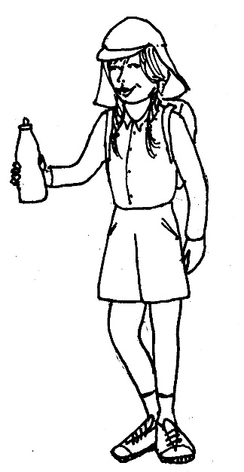
Thongs for the shower

Long pants /shorts (for safety reasons, students must bring at least one pair of long pants)

Shirts / t-shirts / jumpers

Broad brimmed hat, legionnaires style hat or beanie (depending on the season)

Summer (pack to keep cool, prevent heat stress and prevent skin exposure to UV)

SunSmart long sleeved shirts with collar, no singlet or crop tops

Personal water bottle

Winter (pack to keep warm and dry, dress in layers)
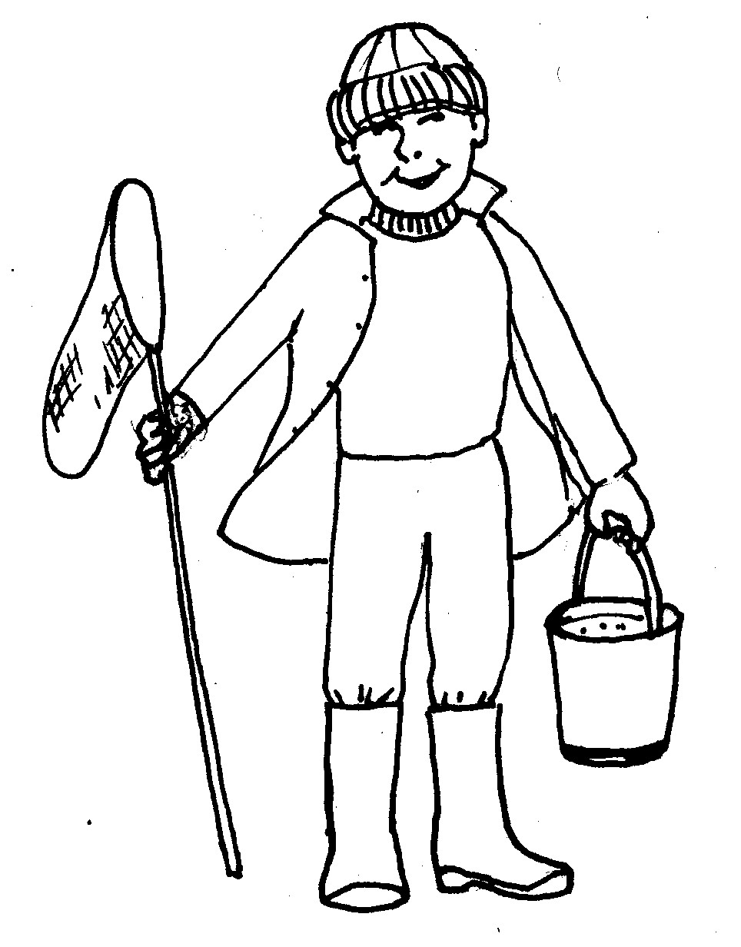

Waterproof raincoat with hood

Additional warm jumpers

Beanie

Rubber boots (if the forecast is wet weather)

Spare clothing including socks and footwear

Sleeping requirements

Pillow and pillow slip

Sleeping bag

Fitted sheet

Other

Torch

Bag for dirty or wet clothes

Toiletries (toothbrush and paste, soap, brush, deodorant)

Sunscreen

Towel

Required medication

This is a generic list – please add or omit gear according to the length of your camp and the time of the year.

What NOT to bring

All meals are included in the camp fee. Please do not bring

any food to camp, including lollies, snacks or cakes.

Extra food can lead to issues of wastage, allergic reactions and illness.

